Have a go, have fun and send photos to your teachers if you wish

Week Beginning | Articles and activities | Events/Festivals
Week 1  20/4/2020 | Article 17 – You have the right to get information that is important for your well-being  What do you do to keep healthy? Think about what you eat, how you exercise and how you relax e.g. drawing, painting, reading stories etc. | Unicef Keeping Healthy Week  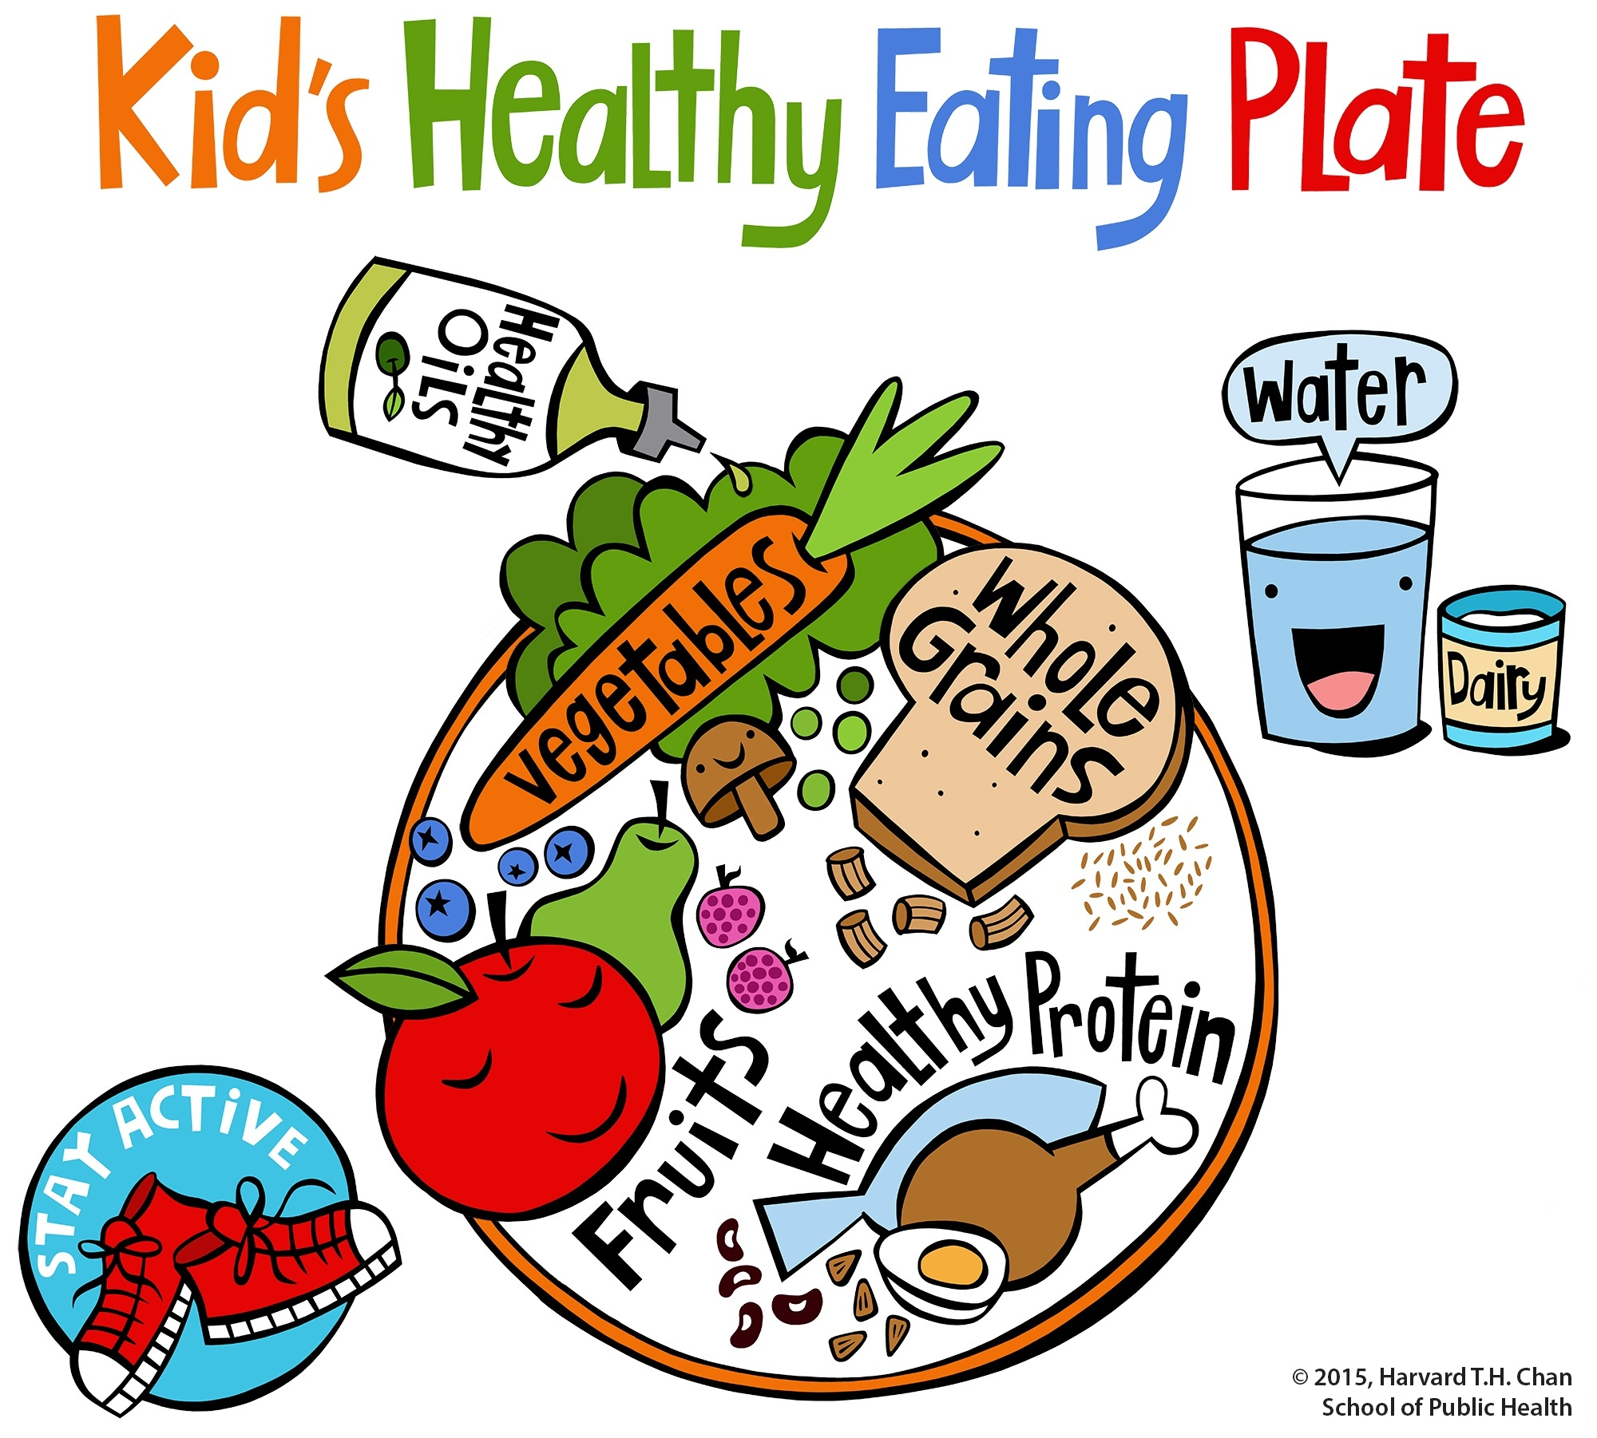
Week 2  27/4/2020 | Article 3 - All adults should do what is best for you  How do you keep active? What is your favourite activity? Which sport do you prefer – can you share it with your friends?  Challenge time: jump on the spot ten times, skip five times etc. | Let’s keep active  The Big Pedal Day 22nd April  Skipping Day 24th April  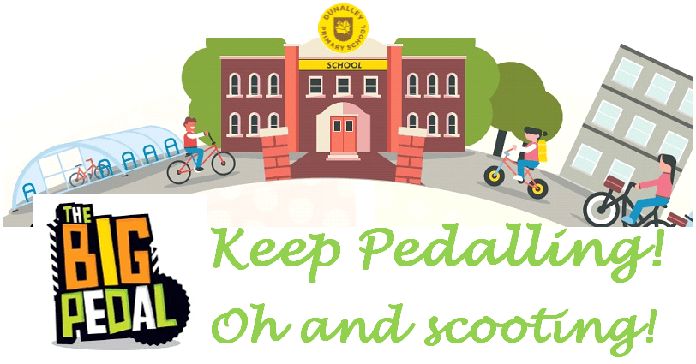
Week 3  04/5/2020 | Article 28 – You have the right to good quality education  What is your favourite story? Who are your favourite characters? Can you play-act it?  Think story-related activities | National Share a Story Month  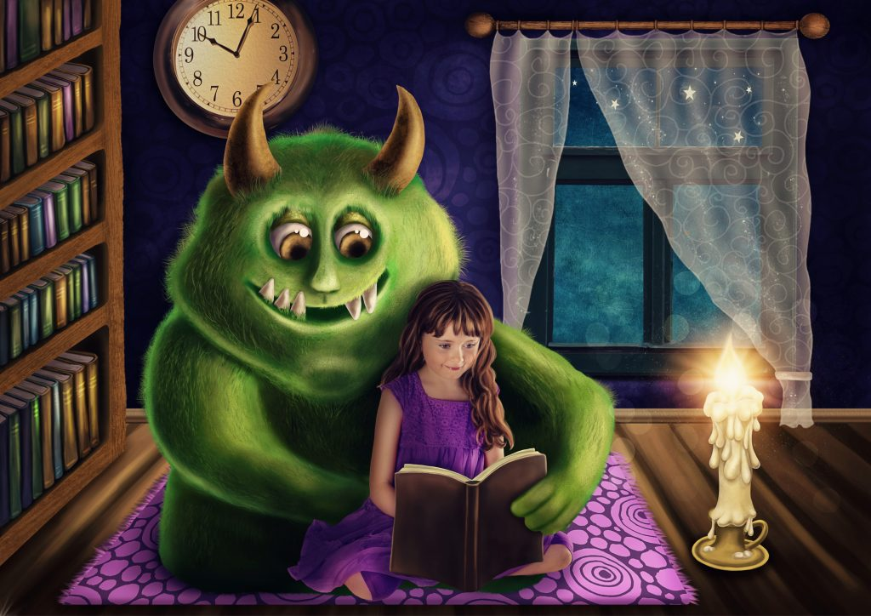
Week 4  11/5/2020 | Article 1 – Every child under 18 has rights under the UN Convention on the Rights of Children  Think about other children around the world. Where do they live? What are their countries like? Think about differences and similarities. | National Children’s Day 17th May  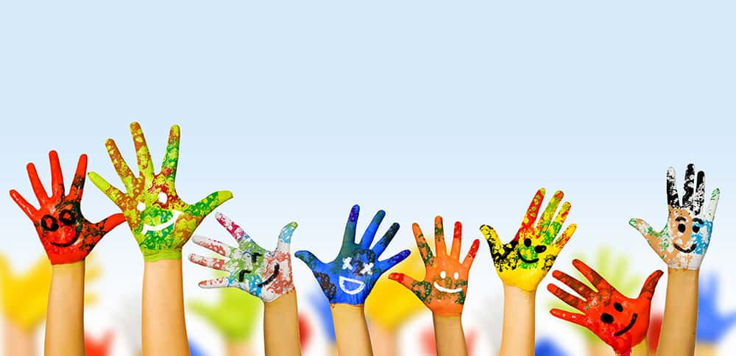
Week 5  18/5/2020 | Article 13 – You have the right to find about things and share what you think with others  What can you grow in a garden? Which animals live there?  Explore gardens and have a go at gardening.  Make a bug hotel, plant seeds in a pot. | National Children’s Gardening Week  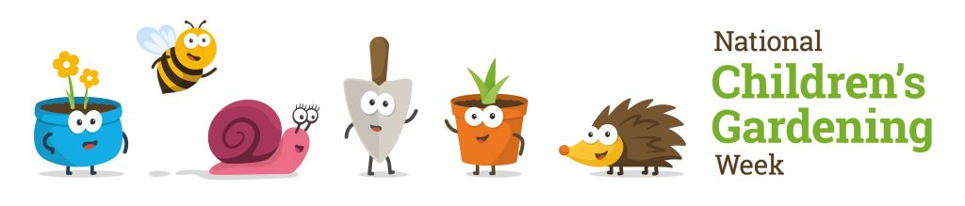
Week 6  01/6/2020 | Article 15 – You have the right to choose your friends and join or set up groups  How are you going to organize it?  Think about food & drinks, decorations and fun activities. | The Big Lunch 2020  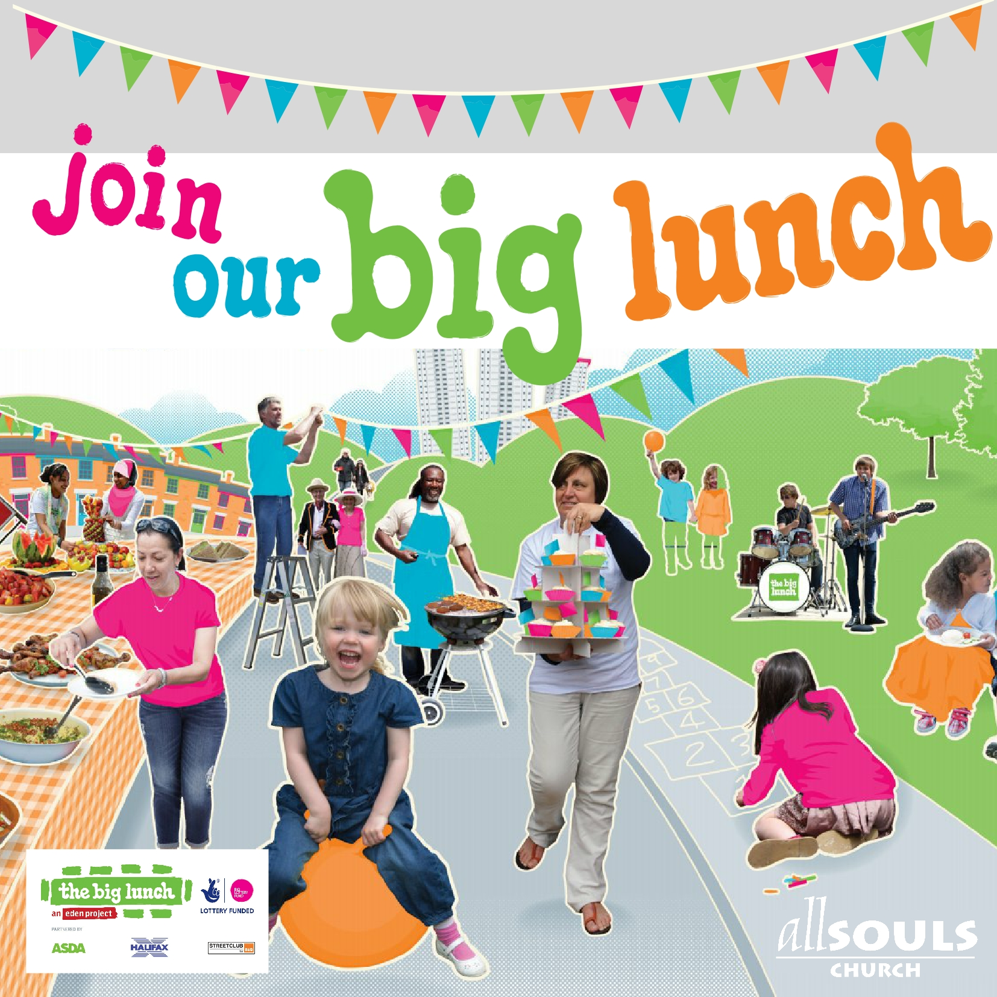
Week 7  08/6/2020 | Article 27 – Your education should help you develop your talents and abilities  Have a go at art work. Think about what you want to create and what you need to do it – paint, natural materials, recyclable items. | Children Art Week  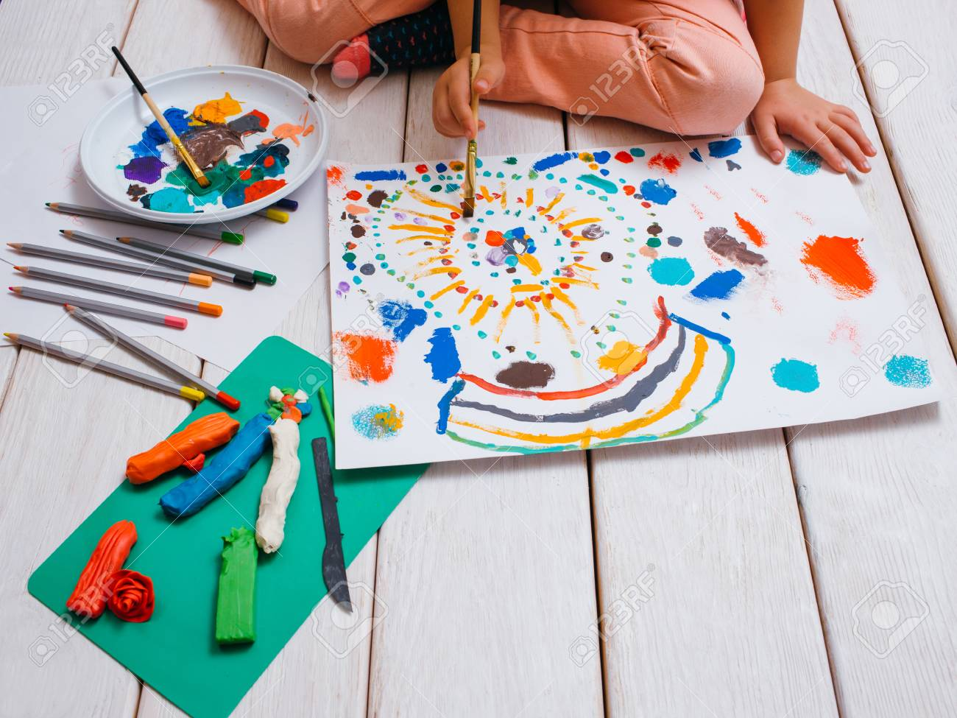
Week 8  15/6/2020 | Article 12 – You have the right to give your opinion  What do you like to write? What do you like to draw? Express yourself! Write a story and create your own illustrations, write postcards and send them to your friends. | National Writing Day 25th June  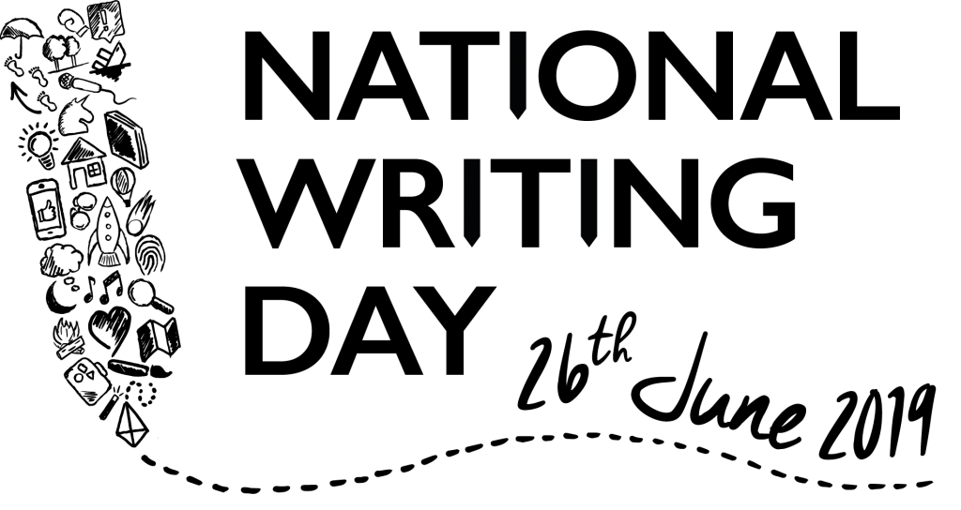
Week 9  22/6/2020 | Article 24 - You have the right to the best health care possible  Dress up and wear ‘wrong trousers’ too. Design characters and dress them up.  What is your favourite film? Who are your favourite characters? | Wallace & Gromit Wrong Trousers Day 28th June  (in support of critically ill children)  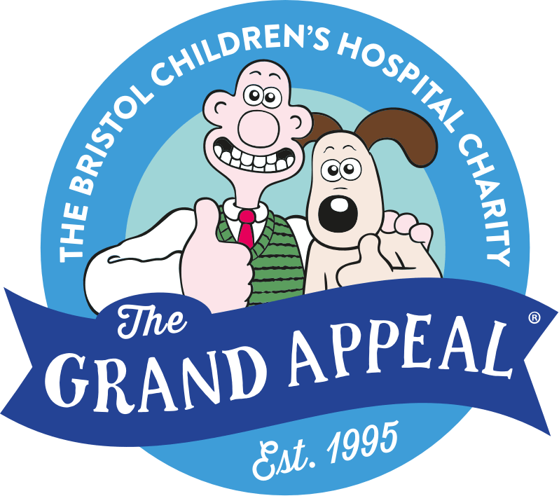
Week 10  29/6/2020 | Article 27 – You have the right to food  How are you going to organize it?  Think about food & drinks, decorations and fun activities. Do it at home with your family or organize a teddy bears picnic. | National Picnic Month - July  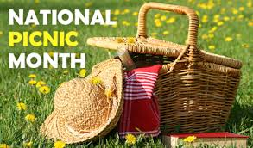
Week 11  06/7/2020 | Article 23 – You have the right practice your own cultural, language and religion  Explore different cultures through music, dance, art, food, festivals etc. Have a go at different languages – can you sing something? | International Day 9th July  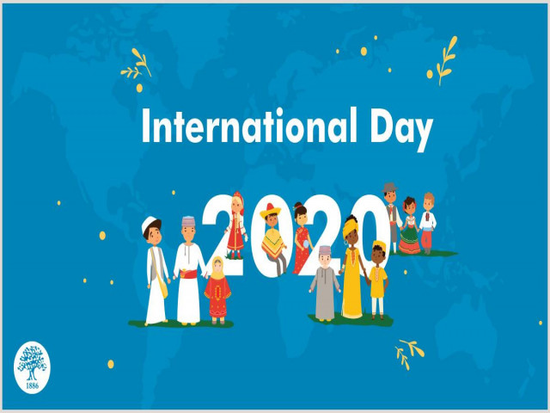
Week 12  13/7/2020 | Article 31 – you have the right to play and rest  What are you planning to do? Who with? Imagine your best holiday ever. Where would you go? What would you do? | Summer holidays  