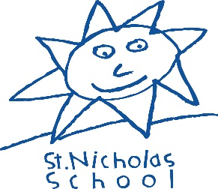

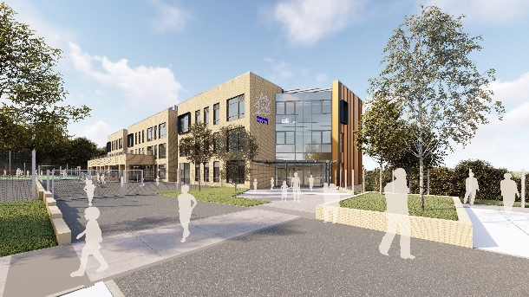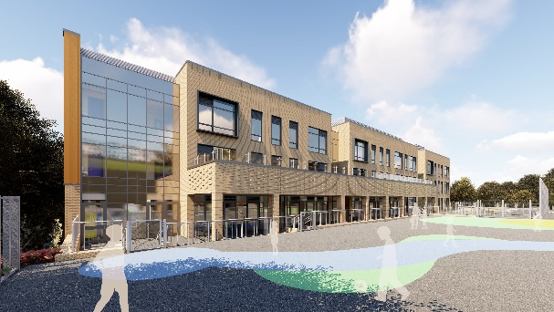

Teaching Assistant Level 2 – St Nicholas School

Are you ready for your next step in special education?
Job Title: Teaching Assistant Level 2
Position type: Permanent
Hours / Weeks: 32.5 hours per week - 8.30am – 3.30pm (5 days per
week term time only)
Salary: NJC Grade 5,scp 13-15 £26,040 to £26,985
which pro-rata to hours/weeks worked as £20,830 to £21,586

Closing date: 23rd May 2022 at 12 noon
Shortlisting: 24th May 2022
Interview date: 8th and 9th June 2022
Start: 1st September 2022

This is a marvellous opportunity for an inspiring Teaching Assistant to join our exciting journey as we embark on becoming an Outstanding provision for children with Special Needs.

St Nicholas is a popular choice for parents of children with special needs in Croydon.
We are rated as a Good school by Ofsted (2017).

We would like to recruit:
- A skilled, patient, enthusiastic and dedicated Teaching Assistant.
- Holding at least an NVQ Level 2 in relevant area.
- Prior experience of working with children with Special Education Needs.

We can offer:

- Excellent career opportunities to work within a vibrant and successful special school on the verge of major expansion
- An ambitious, successful and vibrant place to work
- A supportive working culture that focuses on positive learning behaviour and high expectations for all children.

Safeguarding Statement

The school is committed to safeguarding and promoting the welfare of children and expects all staff to share this commitment. We are an equal opportunities employer and we welcome applications from people with disabilities. The school will request references in advance once shortlisting has taken place. Any offer of appointment will be subject to pre-employment checks including an enhanced DBS (safeguarding) check and satisfactory references. A pre-employment medical questionnaire and completion of documents concerning disqualification of association and other various induction procedures.

References will be requested after shortlisting and before interviews. Applicants should be aware that their current or most recent employer will be approached should they be named as a referee. Please ensure that you provide an email address and telephone number of each referee.
GDPR statement
In line with the General Data Protection Regulation (GDPR) and the expected provisions of the Data Protection Act 2018 (DPA 2018) the school is responsible for holding and protecting personal data. The school is required to share some data with the Local Authority and the DFE. For further information on who we share data with please see our website for our Data Protection Policy and Privacy Notices: www.st-nicholas.croydon.sch.uk

Applicants should apply by using the 3 documents attached to the advert only. CVs will not be accepted. Please include a supporting document (no more than 2 A4 sheets) explaining why you feel you are able to do the job based on your skills and experience with your application form and return by the closing date to suem@st-nicholas.croydon.sch.uk

